**Screenshots:-**

**1. Home Page**

* **Description:** Displays the welcome message "Welcome to NeurofleetX" with a green traffic light and the subtitle "AI Powered Urban Fleet and Traffic Intelligence". The navigation bar includes links to "Home", "Dashboard", "Login", and "Register".
* **Purpose:** Serves as the landing page for unauthenticated users.

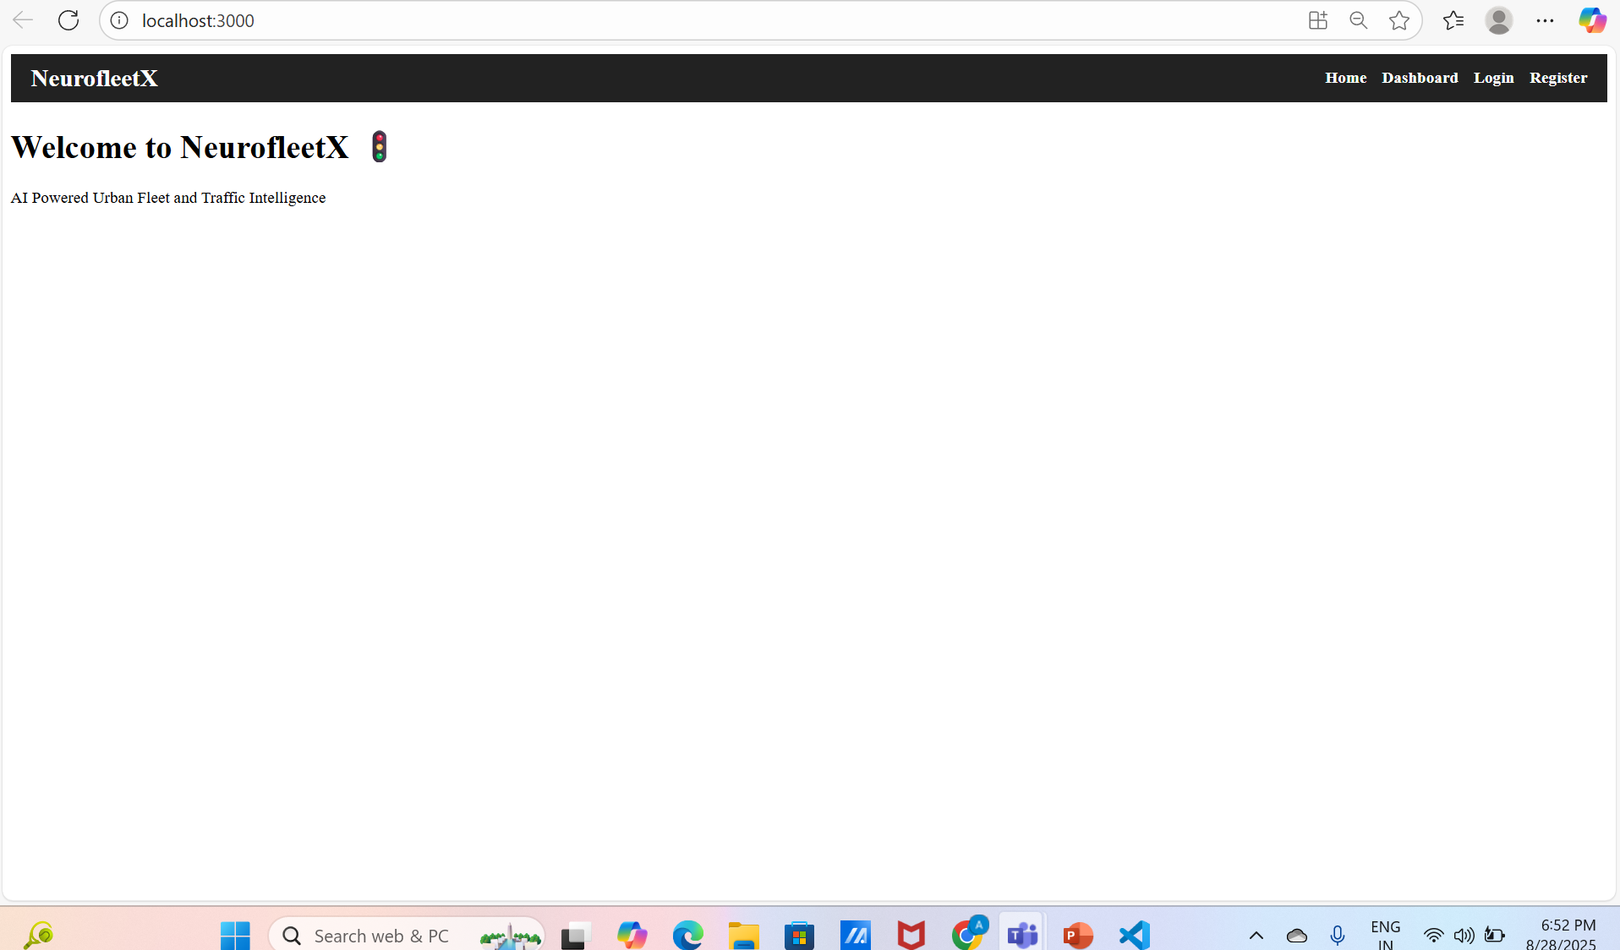

**2. Login Page (Normal View)**

* **Description:** Shows the login form with pre-filled email ("[anuragtiwari3005@gmail.com](mailto:anuragtiwari3005@gmail.com)"), a password field (masked), and a blue "Login" button. The footer link "Don't have an account? Register here" is visible in purple. Navigation bar is at the top.
* **Purpose:** Allows users to log in with their credentials.

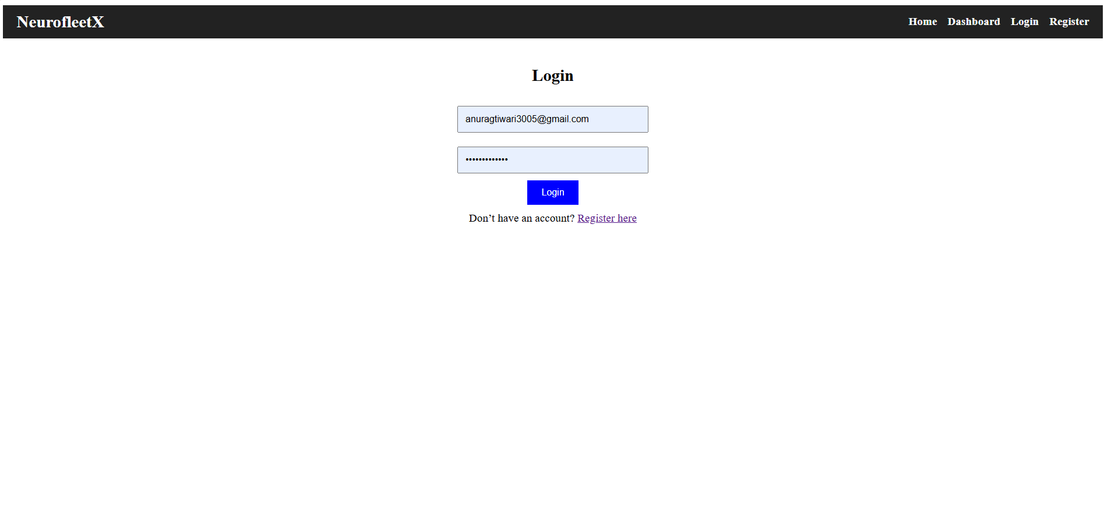

**3. Login Page (Validation Error)**

* **Description:** Displays an orange error message "Please include an '@' in the email address. 'anuragtiwari3005ail.com' is missing an '@'" below an invalid email input. The blue "Login" button remains active.
* **Purpose:** Demonstrates client-side email validation.

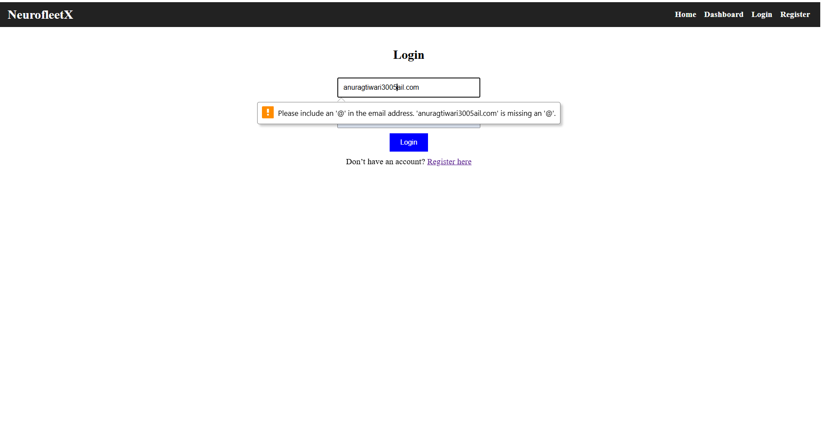

**4. Login Page (Success Popup)**

* **Description: Shows a blue popup toast with the message "localhost:3000 says login successful (dummy for now!)" and an "OK" button after a successful login attempt. The form remains visible in the background.**
* **Purpose: Confirms dummy login success.**

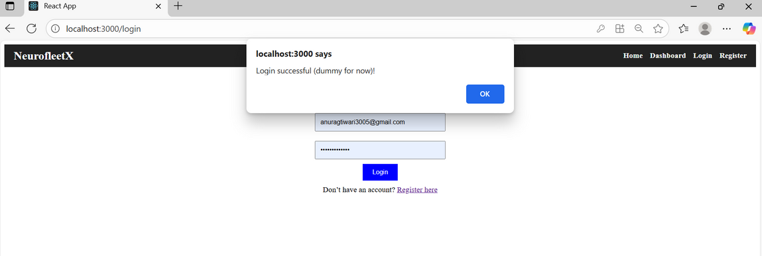

**5. Register Page (Normal View)**

* **Description: Displays the registration form with fields for name ("Anurag Tiwari"), email ("**[**anuragtiwari3005@gmail.com**](mailto:anuragtiwari3005@gmail.com)**"), password (masked), and a green "Register" button. The footer link "Already have an account? Login here" is in purple.**
* **Purpose: Allows new user registration.**

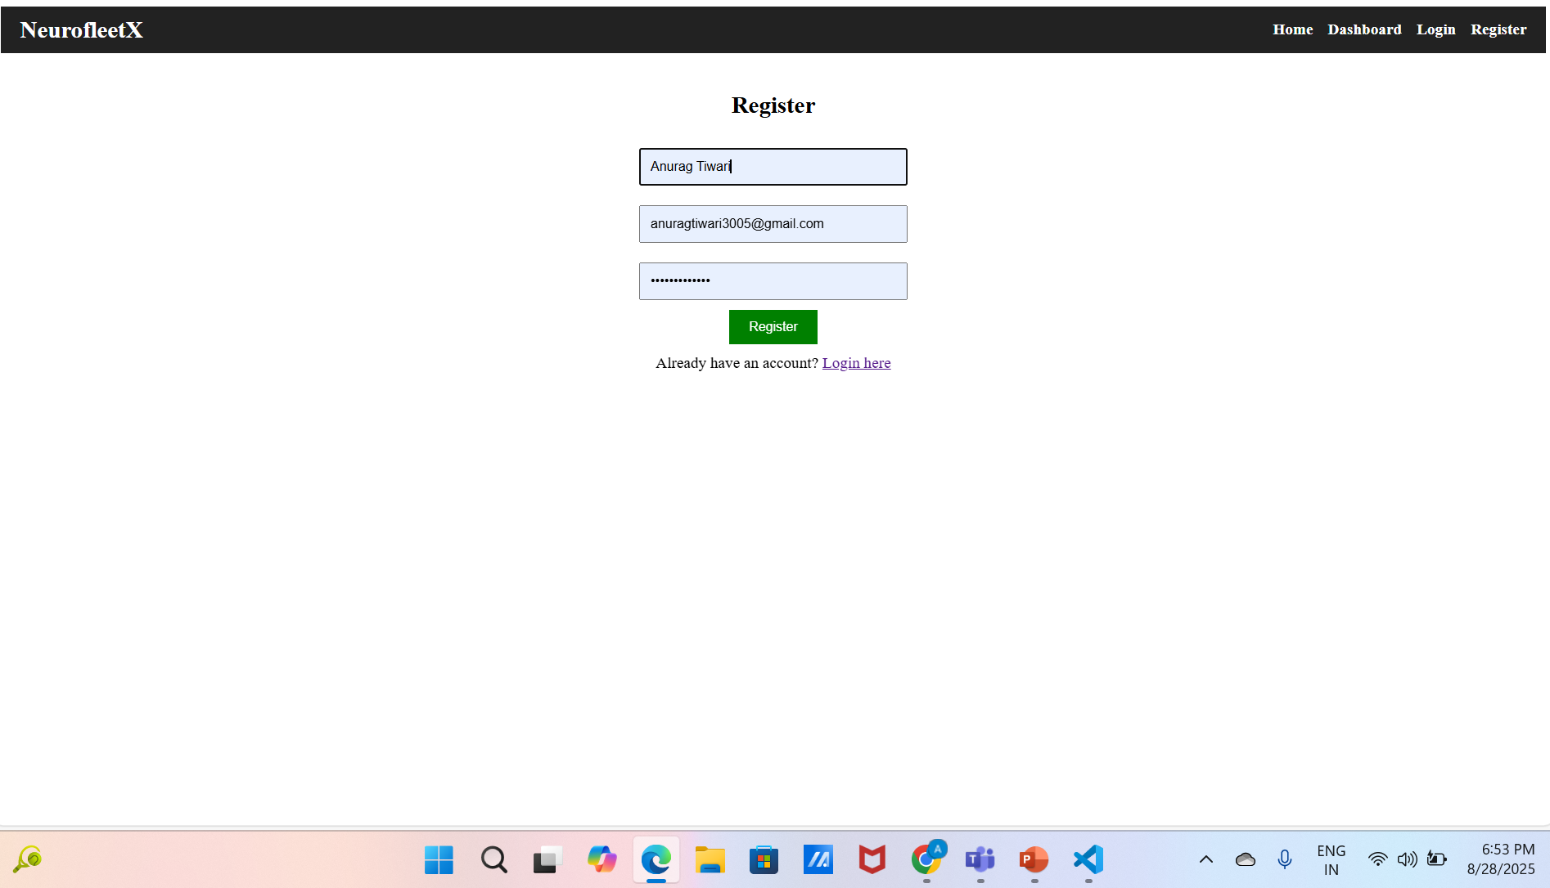

**6. Register Page (Success Popup)**

* **Description: Shows a blue popup toast with the message "localhost:3000 says Registration successful (dummy for now!)" and an "OK" button after a successful registration attempt. The form remains in the background.**
* **Purpose: Confirms dummy registration success.**

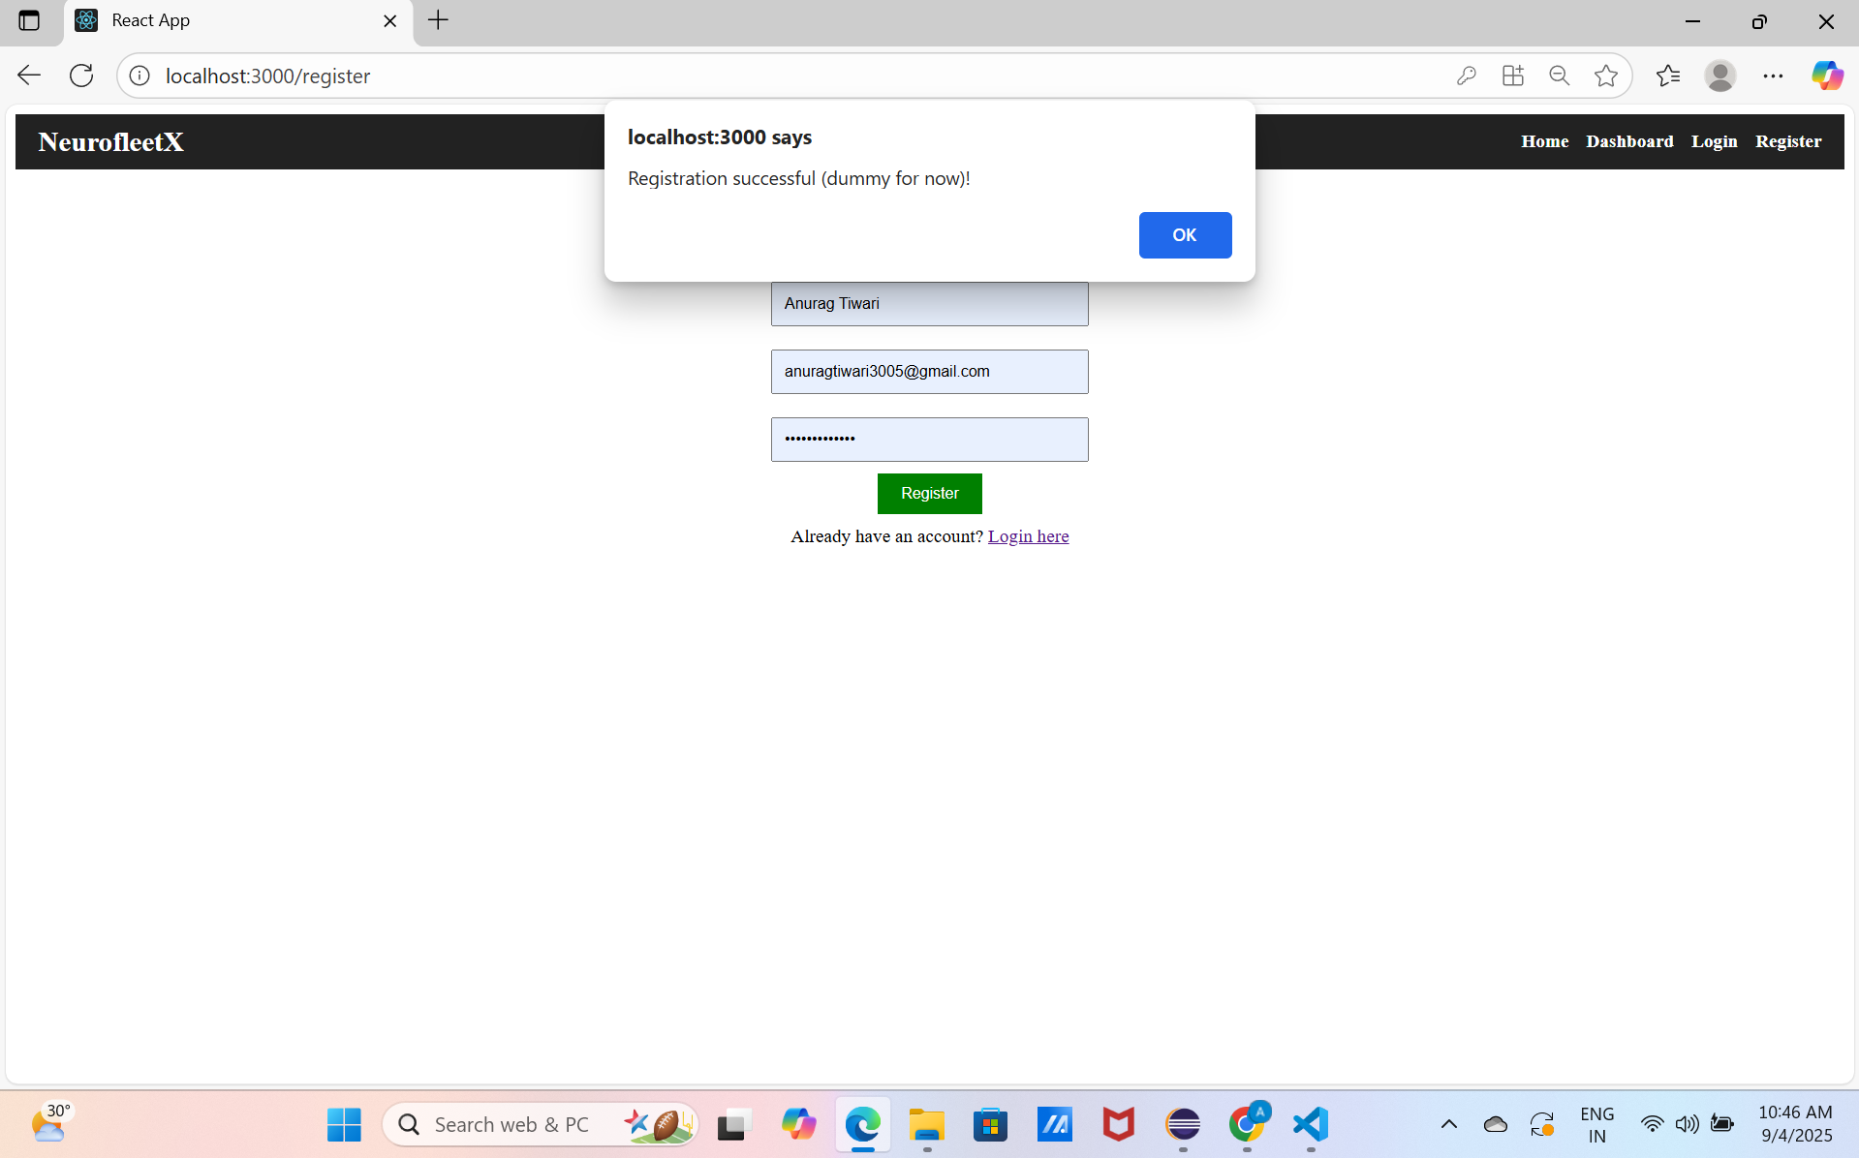

**7. Dashboard Page (Unauthenticated)**

* **Description: Displays the message "You are not logged in " in red with a "Please Login to access the Dashboard" link in purple when accessed without logging in. The navigation bar is present.**
* **Purpose: Restricts access to authenticated users only.**

